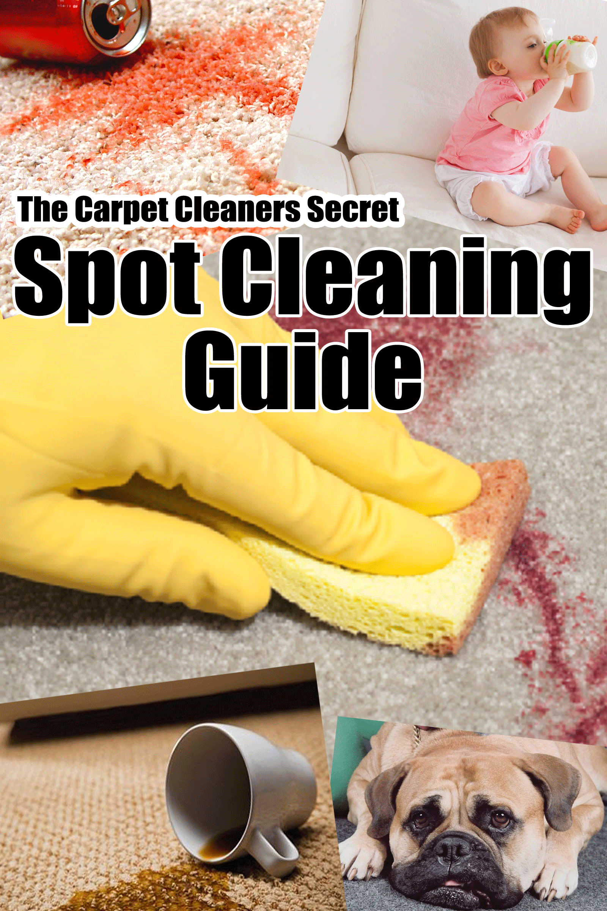

Disclaimer and copyright.

This e-book is a general guide to spot and stain removal and every circumstance and outcome may be different. If you follow the procedures and techniques listed then you will have the best chance of a favourable outcome. It is by no means guaranteed.

Always seek the advice of a professional carpet or upholstery cleaner before acting on something that I have published or recommended.

Please understand that there are some links contained in this guide that I may benefit from financially.

No part of this publication shall be reproduced, transmitted, or sold in whole or in part in any form, without the prior written consent of the author. All trademarks and registered trademarks appearing in this guide are the property of their respective owners.

Users of this guide are advised to do their own due diligence when it comes to making decisions relating to stain removal and all information that has been provided should be independently verified by your own qualified professional. By reading this guide, you agree that myself and my company is not responsible for the success or failure of your decisions relating to any information presented in this guide.

About the author

Peter Marsella is the co-owner of Colonial Carpet Care, a carpet and upholstery cleaning business in Adelaide, South Australia. He has ACCI* certification and has worked in the carpet & upholstery cleaning industry for over 25 years.

Table of Contents
Disclaimer & copyright .2
About the author 2
Table of Contents 3
Before you Start 4
What you need 5
The method 6
Procedure Table 7

Before you start
Hopefully this e-book will be a handy and useful guide and help you to remove the majority of spills without fixing them or ruining the underlying carpet or fabric. If you are at all unsure at tackling any stain I would urge you to contact a carpet cleaning professional for advice.

I’d highly recommend that you print this e-book out. If you then have an emergency situation, it will be close at hand and you’ll be able to act quickly. Remember with any stain or spill, TIME is always of the essence. Usually the quicker you can get to it the better.

Stains and spills on carpet and upholstery are unfortunately an unavoidable fact of life. No matter how careful you are, you can be assured that at some stage something will get walked in or spilt onto them.

Now with that said, the BIGGEST mistake most people make is to just grab the nearest cleaner they have handy, spray it all over the stain and then rub like mad thinking that their mark is going to magically disappear. Sometimes it does, but most often it’s either fixed in permanently or the fabric itself is damaged irreparably.

So before you start there are a few basics you need to know about spot cleaning:

- All stains are not the same! Different stains react in different ways to the chemicals applied to them.
- The fabric itself is delicate and will not respond well to abrasive action. Spot removal is a gentle process!
- Always test the chemical you intend to use on an inconspicuous area first in order to determine that there is no colour bleed or adverse reaction from the fabric.
- If there are solids present, scrape as much as you can with a flat tool such as a blunt knife or scraper or vacuum up.
- When applying chemicals. DO NOT OVER WET! Less is best; you can always gradually add more.
- Always blot stains and work from the outside of the stain towards the center.
- Always finish by removing and rinsing as much of the chemicals used as possible. Do not over wet the fabric or carpet.
- Once the stain is removed and rinsed, absorb as much excess water as you can by either using a highly absorptive super soaker sponge or towel. If possible place a heavy object on top of it for as long a possible to draw the excess moisture out. Drying fans are always a good option as well.

What you need
In order to tackle a wide variety of stains you are going to have to use a few different chemicals, these are listed below. Most of these are readily available around the home or in your local supermarket or hardware store. Some like the enzyme digester you will have to order from a specialist supplier.

- Non foaming spot cleaner – You can use any non-foaming detergent. I do not recommend washing up liquid or powders, they foam too much or contain brighteners. A good choice is Softly wool wash readily available at your local supermarket. I personally use and recommend Professional Choice carpet & upholstery stain remover. It is a non-foaming cleaner, used by carpet cleaning professionals Australia wide and is PH balanced so that it doesn’t strip out the protection from stain protected carpets. Useful for a wide variety of stains but always follow the table provided.
- Acid based spotter – Used for tea, coffee, tomato sauce, red wine, any acid based stain. For this you can use white vinegar in a ratio of about 1:1. Make it up into a spray bottle because you will use it all the time. (It is in fact a great general cleaner too). You can use a mild solution of lemon juice but it does have some mild bleaching properties so be careful.
- Solvent spotters
- a) White spirits - Great for removing any oil based stains, grease, lipstick, mascara, bitumen, chewing gum, blue tac, oil based paints, wax and certain inks. Unlike turps it leaves no oily residue. It is also reasonably safe to use compared to other products out there (I recommend gloves though, just to be on the safe side). It is flammable so caution needs to be taken in that regard.
- b) Methylated spirits – Works really well on Acrylic paint, Biro and other inks.
- c) Acetone (Nail polish remover) – Use as directed on the bottle, use for nail polish and some glues.
- Cloudy Ammonia – Readily available in supermarkets. Use for protein based stains, blood, milk, egg, etc Be very careful using on wool. Dilute 1 part Ammonia to 5 parts water and always test on an inconspicuous area first.
- Hydrogen Peroxide – Pet stains, some dye marks. Use diluted at a ratio of 1 part Hydrogen Peroxide to 10 parts water and be very careful using on dark carpets. Again, test an area if you can first.
- Rust remover – Use oxalic acid if you can get hold of it diluted down with water or you can purchase it ready to use here.
- Enzyme Digester – Available through cleaning suppliers. Nilodor is a good one available here. For use on protein based and organic stains.

The Method
So we have covered the main chemicals that you will use. I would recommend trying to get hold of them all and keep them together somewhere as a stain spotting kit. Print out and pop this e-book in with them and you’ll be ready for any eventuality. Just make sure they are all kept well out of the reach of children and pets.

Most stains require a set procedure and order when using more than one chemical. Further down is a table of the different types of stains and the sequence of chemical applications that has to be followed in order to have any chance of getting the stain out.

This list below is the actual order of procedure you should follow once you have identified what type of stain you are going to treat from the table on the next page.

- Identify the type of stain first before anything else. If you can’t then it will fall into 1 of 3 categories. Coloured, non – coloured or oily and you will have to follow the procedures for what you might think it is from there.
- Always remove any solids first either by scraping them up or vacuuming.
- Follow the exact order as per the table below, When applying a treatment, do not vigorously rub the carpet fibre’s. Always agitate carpet cleaning solution through the carpet with a soft tamping brush or fingers and leave for about 3-5 minutes.
- Once the sequence is completed, rinse the area with clean water and dry thoroughly taking care not to over wet the carpet. If the carpet has been stain treated (scotch Gard, Teflon, etc) you may have to re-apply.
- If the carpet is wool, always finish by rinsing through with mild acid solution.

There are no guarantees with stain removal I’m afraid. What will sometimes work for a stain may on another day on another type of carpet, make no difference. In my 30 years of experience cleaning carpets and treating many many stains, I have to say there is really no certainty that the mark will come out. There are just so many variables. Regardless though I have found from experience that following the steps outlined above, is the best way and has the most favorable outcomes, and so I am confident to share the information.

If you are in any way unsure about how to treat the stain or spill I would suggest you contact a qualified trained carpet cleaning technician to treat it or at the very least give you additional advice.

Good Luck and I hope you find this guide useful!

STAIN | TREATMENT | STAIN | TREATMENT
ADHESIVES | C,D,A,B | HAND LOTION | C,A,B
ASPHALT/TAR | C,A,B | INK (BIRO) | D,C,A
BEER | A,B,G | LIPSTICK | C,A,B
BEETROOT | G,N,B | MASCARA | C,A,B
BERRY STAINS | G,N,B | MILK | C,F, B
BLOOD/BODY FLUID | F,N,B | NAIL POLISH | E,A,B
BUTTER | C,A,B | OIL | C,A,B
CANDLEWAX | S,C,B | PAINT - ACRYLIC | D,A,B
CHEWING GUM | C,A,B | PAINT - ENAMEL | C,A,B
CHOCOLATE | A,B,G | RUST | H,A,B
COFFEE | A,B,G | SHOE POLISH | C,A,B
CRAYON | S,C,A.B | SOFT DRINK | G,A,B
CREAM | C,F,B | SOY SAUCE | A,B,G
EGG | F,N,B | TEA | B,G,A,B
EXCREMENT | F,N,B | URINE - DRY | B,A,G,B
FRUIT JUICE | G,N,B | URINE - WET | A,B
GREASE | C,A,B | VOMIT | B,A,G,B
GRASS | A,N,B | WINE - RED | B,A,G,B
GRAVY | C,N,A,B | WINE - WHITE | B,A,B

KEY

A – Non Foaming spot cleaner i.e. Softly wool wash or Professional choice
B – Acid Spotter – 1:1 White vinegar and water
C – White spirits
D – Methylated spirits
E – Acetone/Nail polish remover
F – Cloudy Ammonia (1 part Ammonia to 5 parts water)
G – Hydrogen Peroxide solution (1 part Hydrogen Peroxide to 10 parts water)*
H – Rust Remover
N – Nilodor Enzyme digester
S – Steam by covering with a white cloth until there is no more transfer to the cloth.

* When using Hydrogen Peroxide, test the fabric in an inconspicuous place first for possible loss of colour. Apply to stain, cover with a white damp cloth and apply a steam iron for 30 seconds. Check for colour transfer to cloth and repeat the procedure keeping the stain and towel damp with Hydrogen Peroxide. When stain is removed or there is no more colour transfer, flush with water and blot dry.

